**Microsoft Azure Virtual Training Day: Azure Data Fundamentals Day 1**

Online free training from MS 28/09/2021

Contents

Resources 1

Introduction – Day1 1

Module 1 - Explore Core Data Concepts 3

Explore Core Data Concepts 3

Explore Roles & Responsibilities in the world of data 6

Describe Concepts of relation data 8

Explore Concepts of non-relation data 10

Explore Concepts of data analytics 14

Module 2 - Explore relational database offerings in Azure 17

Explore Relational Data Offerings in Azure 17

Explore Provisioning and Deploying of Relational Database Offerings in Azure 24

Explore Relation Data Analytics 27

Provision and Query Azure Database 29

# Resources

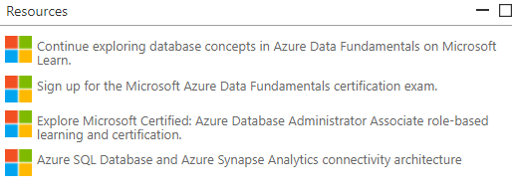

# Introduction – Day1

Learn the fundamentals of core database concepts in a cloud environment. Join us at Microsoft Azure Virtual Training Day: Data Fundamentals to build your foundational knowledge of cloud data services. Explore relational and non-relational data offerings as well as big data and modern data warehouse analytics solutions in Azure.

Attend this training to:

* Learn the roles, tasks and responsibilities involved in managing data in a cloud environment.
* Gain basic skills for working with relational and non-relational cloud data services in Azure, including provisioning and deploying relational and non-relational databases.
* Explore processing options for building data analytics solutions, including Azure Synapse Analytics, Azure Databricks and Azure HDInsight.
* **Welcome!**
* Hello everyone! Thank you for joining todays webinar. There is a list of resources available on your screen now. Please feel free to ask the live moderator questions within this chat box. If you are having technical issues, please click the question mark, Help widget on your screen. Remember to keep an eye on the Microsoft UK Training Days webpage for more events coming up <https://www.microsoft.com/en-gb/events/training-days>/ . Enjoy the session! – 'The Microsoft Training Days' Event Team​
* **Agenda**
* 10.00 – 10.03​ Introduction​ 10.03 – 11.10​ Explore Core Data Concepts​ 11.10 – 11.20​ Break-10 minutes​ 11.20 – 12.10​ Explore Relational Data in Azure (Segment 1 of 2)​ 12.10 – 12.20​ Break-10 minutes​ 12.20 – 12.55​ Explore Relational Data in Azure (Segment 2 of 2)​ 12.55 – 13.25​ Closing Q&A​
* **Free Exam Information**
* Once you have completed all of this training you are eligible to take the DP-900 certification exam at no cost. You will receive a 'Thank You' email in the next 5 working days with steps on how you can claim and schedule your exam. You have 90 days from after the session to schedule the exam. The exam will be online and you will have 40-60 multiple questions with 60 minutes to complete. You have one attempt to pass the exam for free, after this there will be a cost of $99 but we are sure you will pass first time! There are no official Microsoft practice exams. There are several paid options available through LinkedIn Learning, Measure Up, and a number of other providers. However, we recommend that you check out the knowledge checks at the end of each of the modules in the learning path which is the first link in your resources box. Good Luck!

After completing this free training, you’ll be eligible to take the [Microsoft Azure Data Fundamentals certification exam](https://docs.microsoft.com/learn/certifications/exams/dp-900) at no cost.

Here’s what you can expect:

|  |  |
| --- | --- |
| **Part 1** | **Part 2** |
| Introduction | Introduction |
| Explore Core Data Concepts | Explore Non-relational Data in Azure (segment 1 of 2) |
| Break: 10 minutes | Break: 10 minutes |
| Explore Relational Data in Azure (segment 1 of 2) | Explore Non-relational Data in Azure (segment 2 of 2) |
| Break: 10 minutes | Break: 10 minutes |
| Explore Relational Data in Azure (segment 2 of 2) | Explore modern data warehouse analytics in Azure |
| Closing Q&A | Closing Q&A |

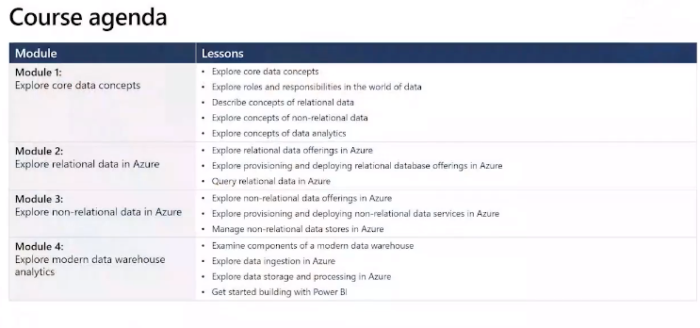

# Module 1 - Explore Core Data Concepts

## Explore Core Data Concepts

Collection of facts

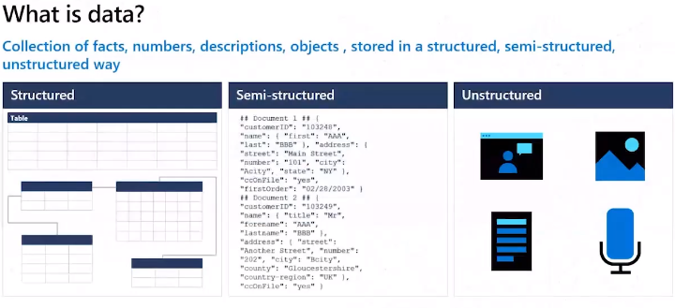

* Structured conforms to schema – same fields & properties, stored in dbase in tables, rows, columns
* Semi-structured – not fit neatly into rows and columns – uses tags and key to organise in some sort of hierarchy = json
* Unstructed – does not follow any schema or structure or organised in any way e.g. image, text, audio

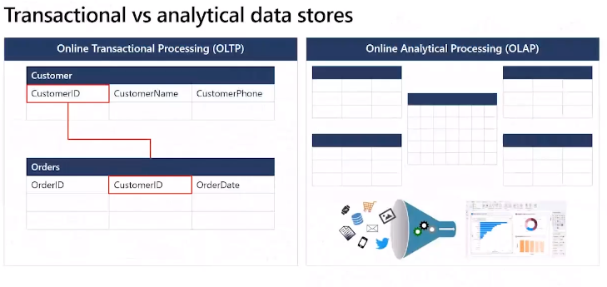

Transaction support operations – small distinct piece of work

Analytical supports decision making process – broad data to gather insights for business decisions

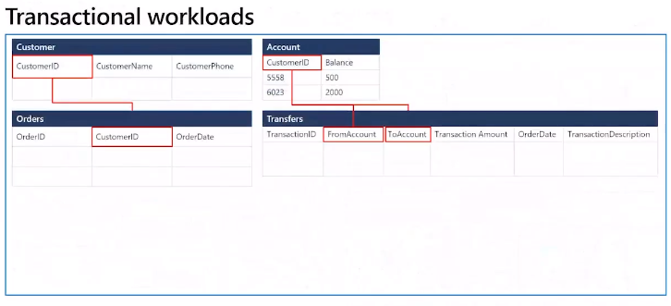

High volumes needs fast processing

Online transactional processing system (OLTP)

Needs to be quick as big data

Divided into pieces – suitable for discrete transactions

Normalisation = fast throughput of data (tables)

This is slow for analysis as need to join tables – but quick for discrete transactions as data organised for transactions

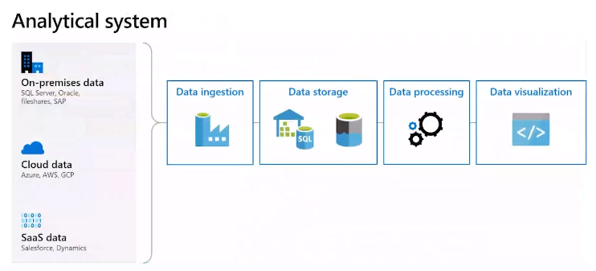

Pipeline of services to build analytical data.

Ingestion – raw data e.g. point of sales data in supermarket, weather data, bank accounts, etc

Can come from OLTP systems e.g. relational database as well

* First store the data into a repository
* Data processing – transformation – standardisations, convert date/address to standard format. Cleaning invalid data, perform calculations like summaries, (KPIs e.g. performance metrics)
* Data visualisation – after ingestions and transformation then query data, trend analysis, problems, etc, then present it in a visualisation way

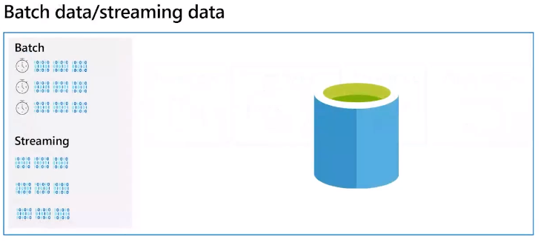

Processing data is how you start ingesting the data

* Streaming – process as arrived  
  Useful for new dynamic continuous data, no waiting/time-delay; use cases = new dynamic data generated on a continuous data
* Batching – batch into groups then schedule processing – interval (hourly), trigger (x number data items). Can process at a convenient time e.g. overnight.

Disadvantage of batch – time delay.

Need to ensure data quality or could fail processing

## Explore Roles & Responsibilities in the world of data

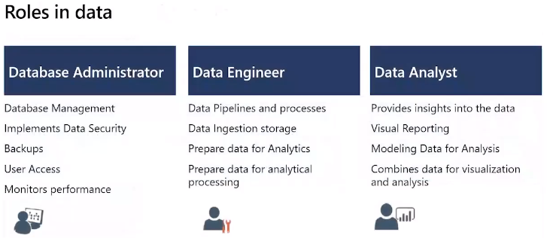

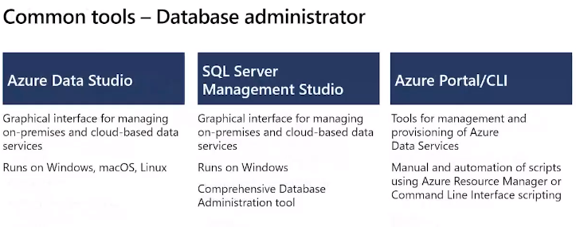

Configure tools to maintain performance, optimise data services and availability. Ensure data policies e.g. backups, security (access rights)

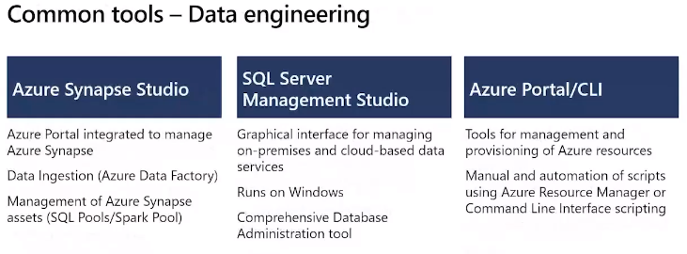

Maintaining data privacy in cloud and on-prem, manage/monitor data pipelines and stores. Clean and transform data. Prepare data for data analysis.

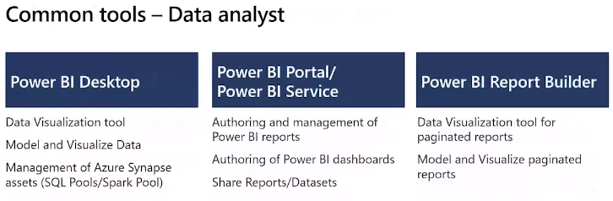

Build and maintain data models and visulisations. May involve cleaning data.

Turn data into insights that are actionalble.

## Describe Concepts of relation data

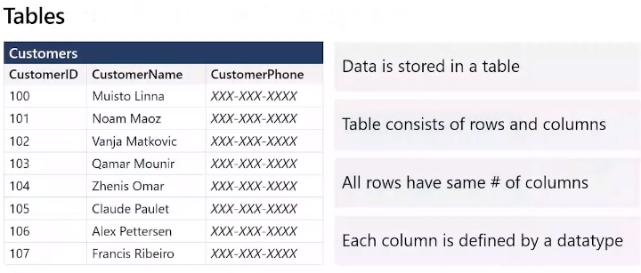

Collections of entities in the real world as tables

Row represents a single instance of an entity – each row defines a single product in the products table

Columns – properties of an **entity** – id, name, phone number

All rows have same number of columns

Some columns are used to link to other tables – keys

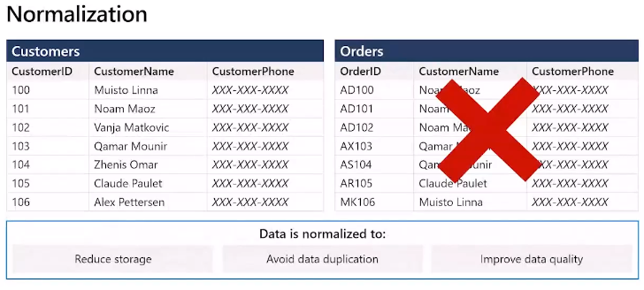

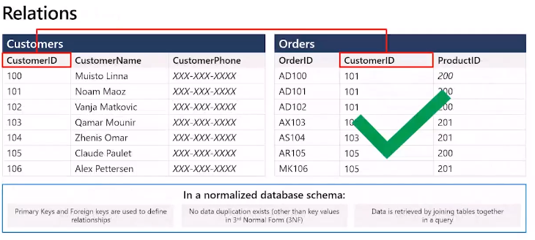

Create data model

Link tables using primary keys – associate with foreign key in another table.

Establish relationship between tables

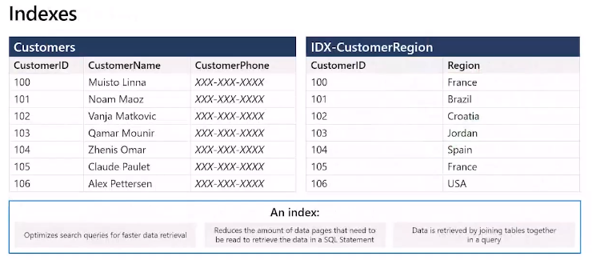

Helps find data in a table

Like a book index

Column that holds the index – helps query find the data more quickly as do not need to scan full table. E.G. region

Index speeds query but slows processing

For query/read-only – good to have indexes

For transactional (insert/update/etc) – bad to have index as slows down processing.

Index cost – operational cost as need to update index when inserting/changing data, need to rebuild index also takes storage space

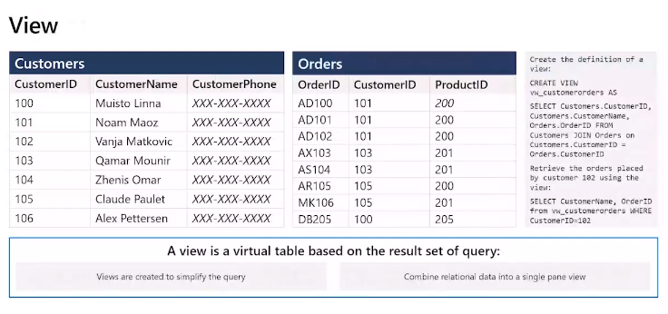

A view is a virtual table.

Views can join tables.

## Explore Concepts of non-relation data

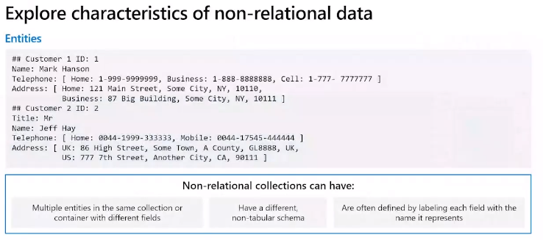

Lack of fixed schema means can be more flexible – each can self describe the data

Each entity does not have to have the same fields

Has labels to define attributes/fields

Enable store data flexibly – cos do not impose schema

Focus on data itself rather than force structure – can match to how will use the data

Fields prefixed by name and can have sub fields – noted by sub brackets – see above

When add new then insert a new entity to this data store

Data retrieval must be able to parse this data

Data retrieval capabilities vary

Each entity should have a unique key value (e.g. ID)

Usually stored in key value order

Simplest allow specify a key or range of keys for each entity.

Example above – query customer by id only. If want to query on a different attribute then need to scan full data set

Query to fetch customers on ID quick

If not key field e.g. Title then must scan full data store so very slow.

Azure Cosmos DB supports non relation, that supports querying now key fields from an unstructured DB (indexing like indexes on rdbms)

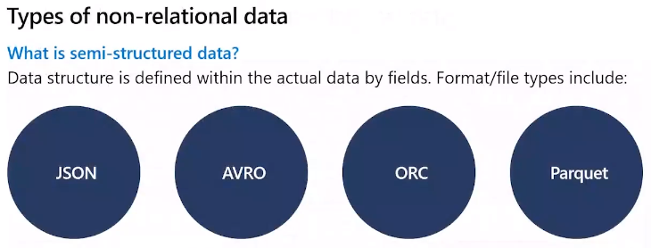

Entities only need define the attributes it holds. Must be able to parse with a parser.

**JSON** – enclosed in curly braces, each field has name followed by colon then the value

If follow json grammar can store attributes, arrays, objects. As long as follow grammar can include any type of data/doc as a value in the json

Need use json parser to break data into it’s component fields

**AVRO** – apache

Row based

Header stored as json

Data stored as binary

Parser to read the binary using the json header

Good for compressing

**ORC** – Hortonworks, HIVE

Optimised row/column data

Supports sql queries

Strip – index to row

Footer contains stat info – sum, count, max/min – per strip

**Parquet** – row groups

Data for each column stored in same row groups

Contains metadata to describe rows in each chunk

Developed for storing and processing nested data types, compressed data

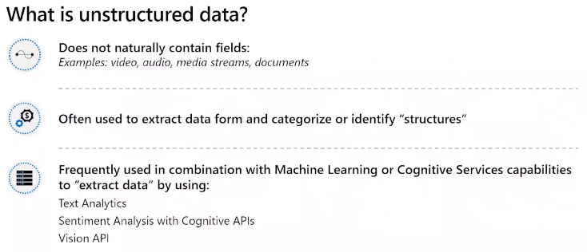

Each data item is a blob

Binary Large Object (BLOB)

Cannot search for specific data within these data stores

Azure Blob storage

Blob blocks use for read/write operations, no internal query facility

Files can be stored as blob - Fields & meta data (properties of the file – owner, creation data, etc) but content of the file is unstructured.

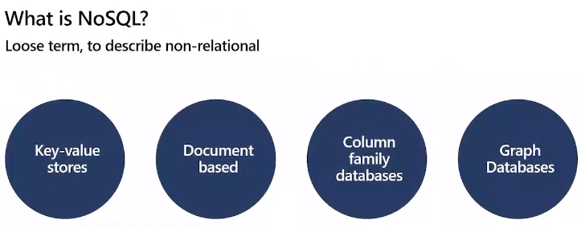

**Key-value** **store** – simplest for ingestion of large volume

Opaque = cannot see the values only the keys (relational DB is transparent as can see all values)

Need key = id to item

Value = item

Sees value as an unstructured block of data

Restricted to inserts and deletes

Retrieve, modify and insert back to key/value store

Read & write quickly – continuous stream

Not good for query

Azure datastore = key/value

**Document**

Typically use json format but can use others, xml, plain text etc

Exposed to storage management systems = transparent

Allows query by using values in the fields

Document contains all values and attributes of a document not spread over tables like rdbms

Does not require all the documents to have the same structure

Applications can store different data in documents as requirements change

Retrieve by document key – some apps create auto key others need you to specify

Some Document databases allow indexes

Fast to load documents

Main goal – search/query that Key-value store

Must specify key and if index then those too

Main goal is search query capability that key/value store does not

Azure Cosmos DB implements a document database

**Column** family database

Stores column & rows - denormalised

ORC etc

Can define column families – logically grouped together e.g. customer & housing and can then fetch at same time

Diff from relational dbase which normalised

Like virtual treasure hunt – 10min vids with secret letter, to get the full word. Hidden at 4 min mark for each vid. Video is column family with 4 min mark as key

Organise to optimise common queries

Example – Apache Cassandra

Search column family and key = row(s)

Azure Cosmos DB supports thru Cassandra API

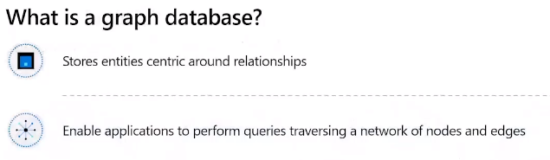

Nodes = entities

Edges = relationship and nature of relationship

Enable perform queries quickly using nodes and edges and relationships between

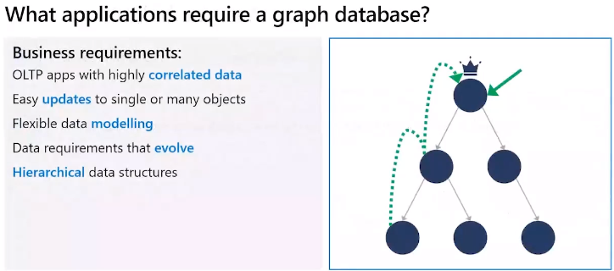

Each node is the entity (person)

Each Edge shows the reporting line

Find all employees who report to same manager

Performs complex queries quickly – who works in the same dept as me

Traverse the network of relationships

In SQL may need expensive recursive joins and nested subqueries

Azure Cosmos DB supports this thru Gremlin API for navigating and querying graphs

## Explore Concepts of data analytics

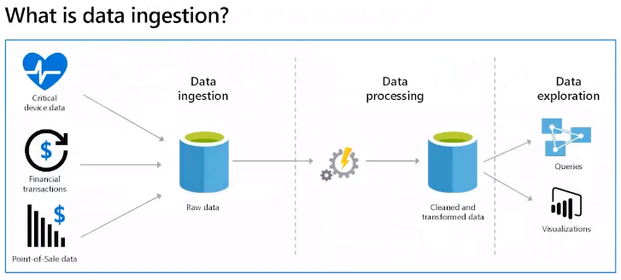

Helps identify strengths and weaknesses in organisation to help business decisions

Get data from all sources and put into a data warehouse to allow analytics

Need to transform and format data for query

Can then use analytic and visulisation tools to explore the data

**Ingestion** process – captures data from various sources.

May process immediately (continuous stream) or store to batch process later

Can check data – security, quality

Transform data – standardise formats e.g. date/time, same metrics.

Keep quick don’t run complex calculation – do this later

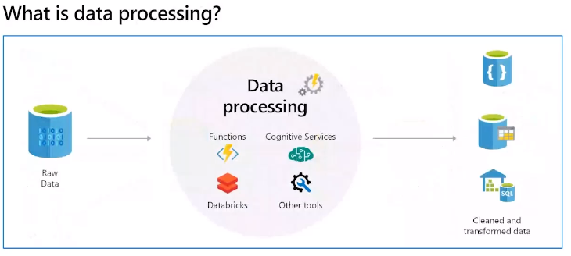

Aim to convert raw data into a business model

Meaningful business entities, aggregation, generate predictive and analytical models

Can be complex and use various scripts so use tools

Azure data bricks, functions, etc to reformat/transform the data

ETL – extract transform and load – before being saved – standardised, clean, transformed, calculation, deduplicate, etc

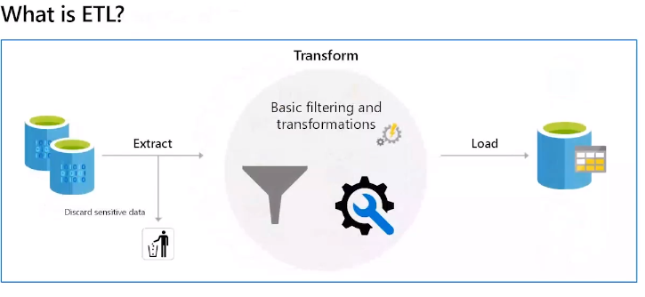

During transformed the data may cleaned, standardised, fix missing

Load into a dbase

Good for simple models, where independent entities

Stream orientated – can be performed in a continuous workstream

ELT – Extract, Load & Transform

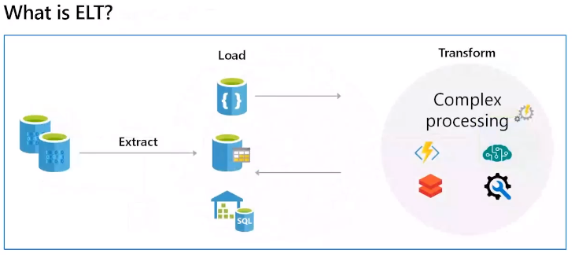

Iterative approach

Good for batch processing

Complex where not independent entities, often using period batch processing

More scalable for cloud usage

Stream orientated

**Azure SQL database**

SQL server integration services to build out ETL and ELT pipelines

**Azure Data Factory**

Create data driven workflows and pipelines

Process and ingest at scale – data flows aka pipelines

Data movement and transform at scale

Build pipelines

Azure HDInsights, Data Bricks, Azure data bricks etc

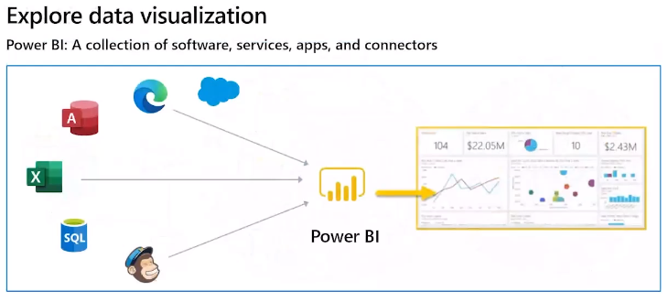

BI – tech, applic & practices for collecting, integration and analysing data and presenting business info back to the business

Aim to support better decision making

Current and historic and current data

Can use data from warehouse, live data feed, S/S, etc

Can provide interactive slice and pivot and data mining

Can target areas – sales, production, financial etc to see how performing against industry, market

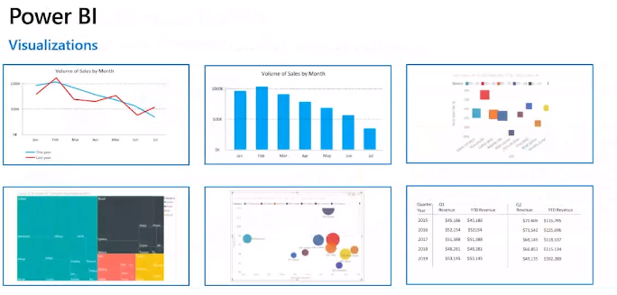

Focus on meaning of data rather than data itself

Trends, issues, etc

Lots of different visulations

Bar & Column – how variable changes over time

Matrix – tabular structure that summaries across data

Key Influences – key influencers of data attributes

Line – show trends over time

TreeMaps – coloured rectangles – sizes represent value of item

Scatter Plot – relationship between 2 numeric values

Bubble same as plot but uses bubbles instead of data to represent data size

Field Map – geography – regional relative differences, light – less frequent to dark = more frequent

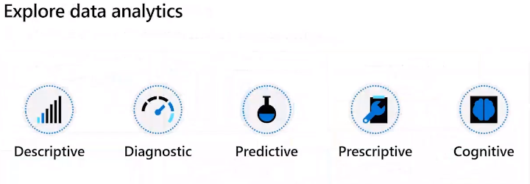

* Descriptive – ask and answer questions what has happened based on historic data. Uses summary to highlight e.g. reports provide view of sale and financial data
* Diagnostic – why is this happening. Root cause. Taking findings from descriptive to diving deeper to diagnose cause. Identify anomalies, collect data relates to anomalies, use stats methods to discover relationships and trends to explain these anomalies.
* Predictive – what will happen in future based on previous trends and patterns. Use historical data to identify trends to and if this is likely to continue in the future. Stats, Machine learning and other techniques, neural networks and ….
* Prescription – what actions need to happen. Uses outcomes from predicative. Make informed decisions in face of uncertainty, machine learning to find patterns, past events and likelihood of same/different outcomes.
* Cognitive – how the human brain works. Attempts to draw inference from existing data and patterns. South learning feedback loop. What might happen if circumstances change.

# Module 2 - Explore relational database offerings in Azure

## Explore Relational Data Offerings in Azure

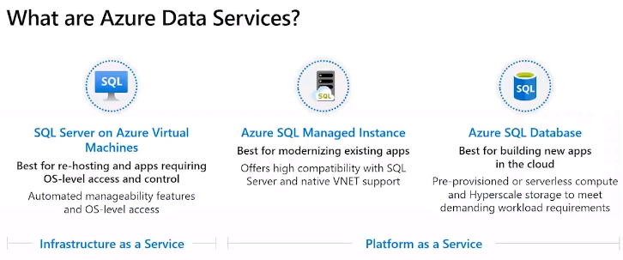

Range of options to host relation dbase on the cloud

**IaaS** – same as on-prem

You responsible for configuring and managing dbase services

But don’t need to buy/manage infrastructure/hardware as VM

Virtual infrastructure in the cloud mirrors on-prem

Can have virtual networks and machines

**PaaS**

Infrastructure/hardware done for you

Specify resources you require – size, users, performance

Azure creates machines, networks and other resources for you

Can scale up/down quickly – auto handles scaling for you – add/removes VMs or perform configuration

You concentrate on the data

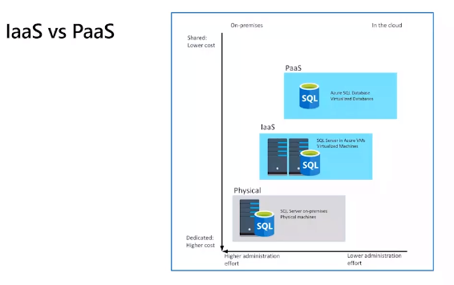

You create dbase and Azure managed and looks after service for you

Reduces time on admin on dbms

Guartees up and running 99.99% of time

Can support mariadb, postgresdb & MySQL

**Limitations**

DBMS – custom software, runs scripts as part of DB. Cannot do this in PaaS as can introduce vulnerabilities and security.

Costs – base price underlying infra, licences, always on

No direct control over platform

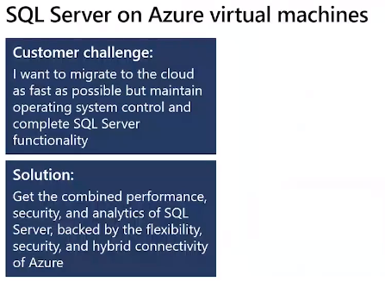

Can run SQL Server on Azure virtual machine – full version of SQL Server in cloud without the infrastructure. Full admin rights on VM. IaaS approach.

Lift and shift with minimal changes

Can quickly scale / resize Azure VM.

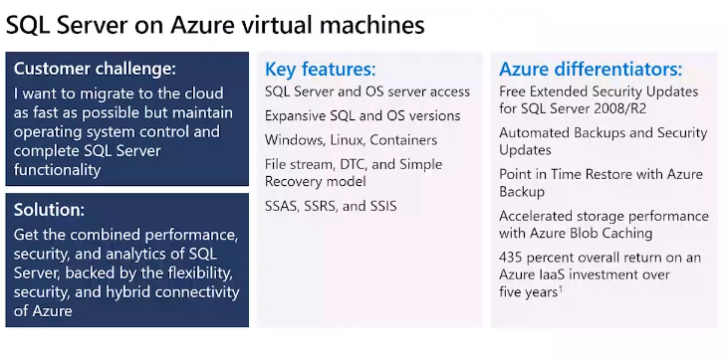

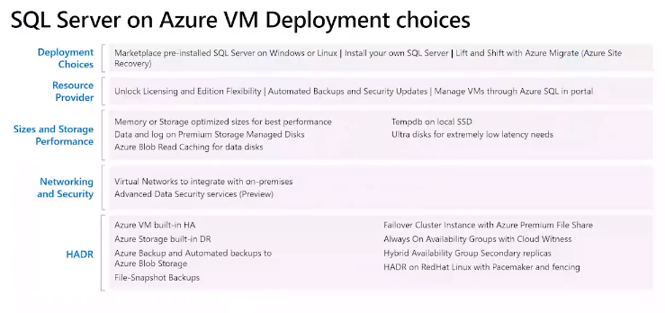

HADR – high availability and disaster recovery

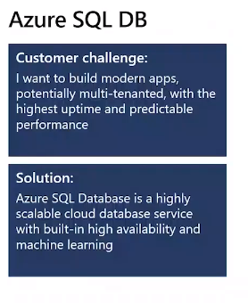

PaaS offering – managed data service in the cloud

Can deploy your DBsase to the cloud server

Single dbase, elastic pool, scalability, managed instance

Low cost, manageability

Not fully compatible with on-prem SQL server

Now cloud projects here application design can accommodate PaaS rules

Good for variable load and high availability

Auto updates and patches – latest version of SQL Server DB, scale up/down, high availability guarantee

Point in time restore, regions

Advanced threat protection – including anomaly detection, continuously monitor dbase for suspicious like sql injection attacks – alerts with suggestions

Writes logs for analysis

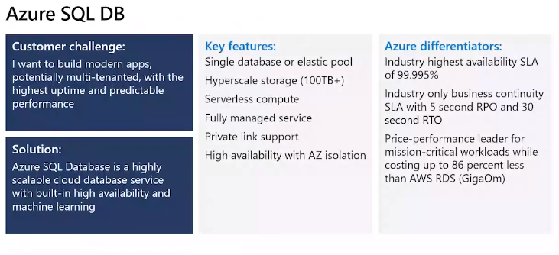

Point in time restore

Advanced threat protection – detect and remediate security/anomalies activities. Continuous monitor and immediate alerts e.g. SQL injection attacks.

Audit logs available

Adds encryption

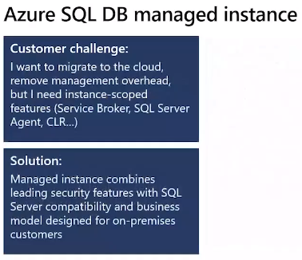

Allows run fully controllable instance of sql server in the cloud.

Multi dbase on same managed instance

Automates patching, backup, etc

Still have control of security and resource allocation

Services done for you so less admin required.

All comms encrypted, uses certificates

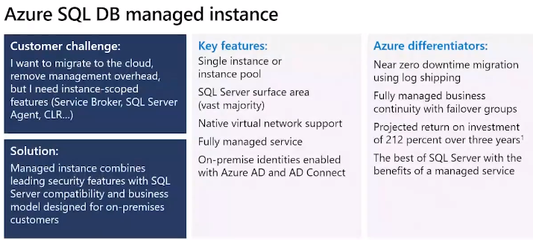

Linked servers

DBase mail

Etc

DBase managed service compatibility tool

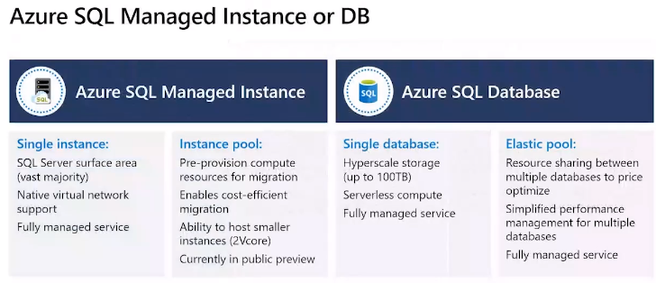

Managed Service

All you do is create dbase and load data

Charge per hour of the resources you have allocated

Can share resources with other users but your dbase private to you – cheaper but database is kept private to you

Elastic pool – multiple dbases share the same resources, like memory, CPU e.g. end of month payroll dbase uses all resources. Can scale and release when process is complete.

Only used by you, not shared with other companies.

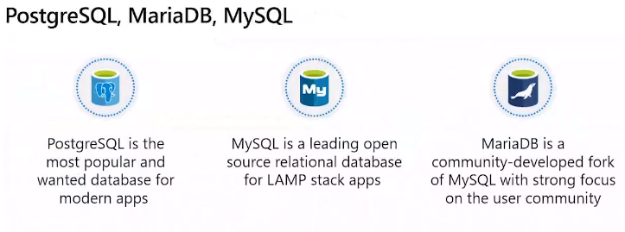

Other Azure services if you use other Dbases types so can move to Azure more quickly and keep your current database type.

PostgreSQL allows you run your own code/stored procedures in the PostgreSQL. Store and maniputate geo data – pgsql variant.

MySQL – community, standard & enterprise editions, under hood runs on linux. Enterprise editions has enhances security, availability and scalability

MariaDB – newer dbms. Dbase engine rewritten of MySQL to improve performance and can integrate with OracleDB. Notable feature support for temporal data – time based.

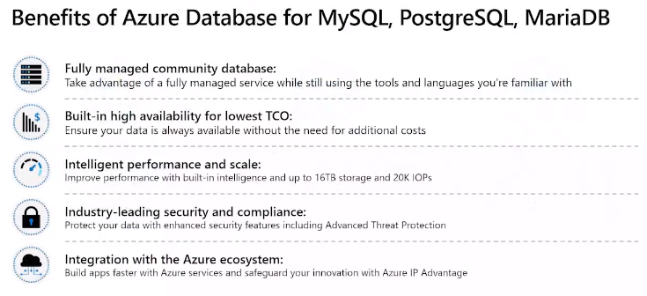

Backups automated with point in time restore (35 days in past)

Can enable lock modes, max connections, etc

Global dbase system that scales up without doing patching, etc

Limitations – customisations to Azure MySQL dbase not available due to security vunerabilities

MariaDB benefits same as MySQL

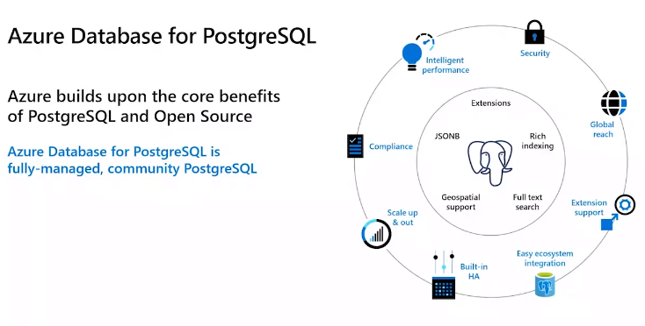

Single server or Hyperscale options

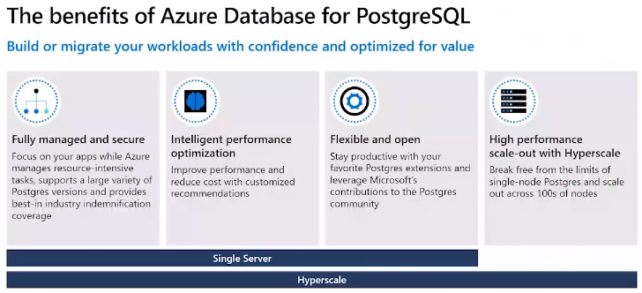

Select size/price to meet your requirements

Provisioning parameters

Azure provisions the resources and makes available to user

Highly available built in failures actions

## Explore Provisioning and Deploying of Relational Database Offerings in Azure

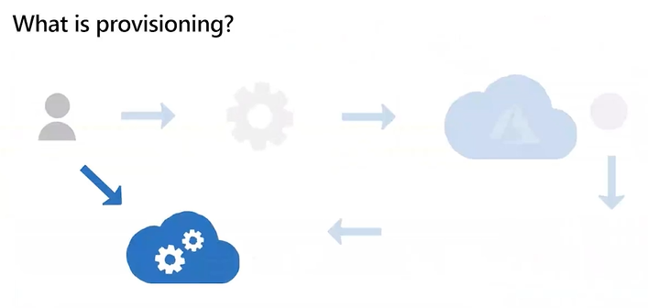

Say what you need, provide parameters then auto provisioned and ready for use

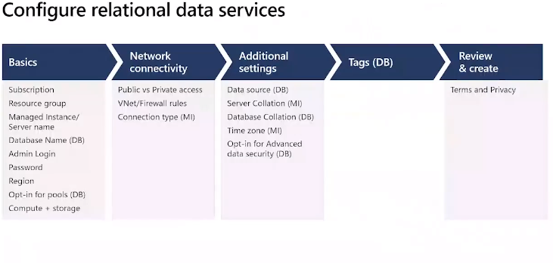

So to setup go through steps above suppling the parameters specified in ‘Basics’

Database = none = new or backup = existing dbase you want to migrate to this server

Pricing Tier – specify small = dev/test, General = basic business use, memory Optimised = high performance with in-memory processing for in memory for high performance

Can scale up/down later on

Limitations on dbase name, admin username, password

Then click create = provision dbase service for use

Can modify after provisioned.

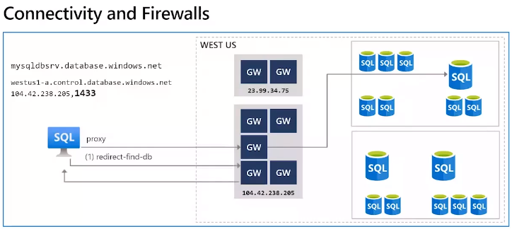

Default of use proxy or redirect.

Need network admin to open port (1433) if required

Need to allow connection through company VPN – firewall rule to specify ip address range

Connection policies – redirect is recommended – lower latency and higher throughput. Needs outbound comms to all Azure services/gateways

Policy of redirect required for in/off premise gateways

Choice impacts speed of throughput.

External connections need proxy rule.

Default connection policy – redirect all client connections originating inside Azure and proxy all client connections originating outside Azure (on-prem).

On-prem – allow traffic through corporate firewall, proxy policy by default

Inside Azure – redirect by default

Use groups and tags

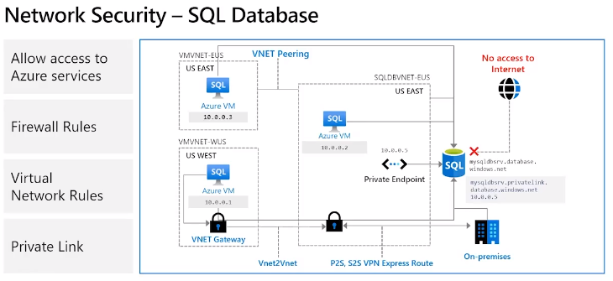

Can configure – firewall rules, network rules, private rules

Private endpoints = block off public access

private end point = private connection with private ip address to bring into virual network

Can use vpn gateway

Can block off public internet access so on-prem can connect to Azure to prive ip address space

Can use network pairing so can group to connect and use same private end point

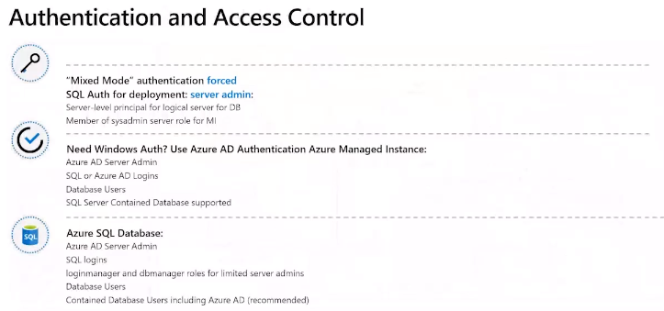

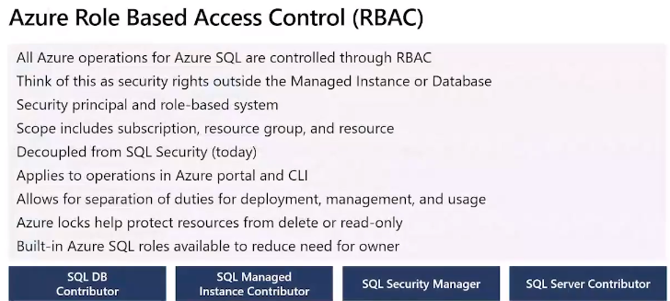

Critical for cloud-based services

Who has access and what they can do

Allow user to manage dbase in a subscription

Another user could manage resources

Allow application to access resources

Role Assignment

Security principle –

Role definitions – collection of permissions e.g. crud, has built in roles – owner = full access,

contributor = create and manage resources but not grant access, reader = can read but not

update

Scope – lists resources roles/resources can access

e.g. role and scope

Role is limited by scope e.g. web based role but limited scope to 1 resource.

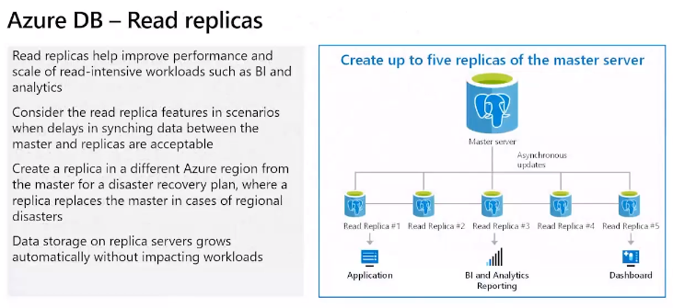

Read repicas for data source for read only – analytics

Not require for write so runs quicker

Replicas are new resources that are built and billed as per other resources.

Different management and pricing

a-synchronist from master so can be delays from master to all the replicas

Not good for write based.

Can geo-replicate across regions

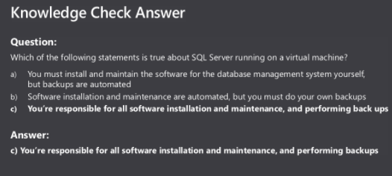

## Explore Relation Data Analytics

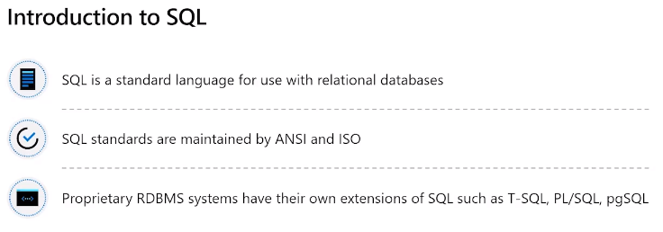

Updating and retrieving data from a database

Different dbases use their own variations/dialects of SQL

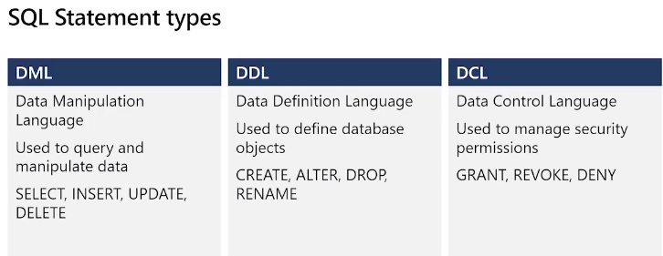

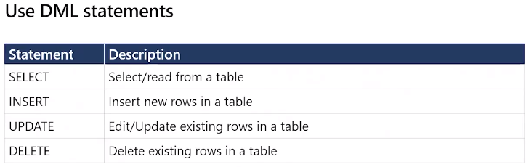

Different companies have their own propriety features/dialects only available in that language e.g. Oracle SQL, MtSQL, Ingres SQL

Proprietary features allow various specific actions only recognised in that flavour of SQL

Can include stored procedure, managing user accounts.

TSQL – Transactional SQL

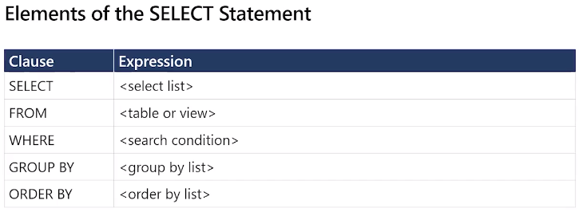

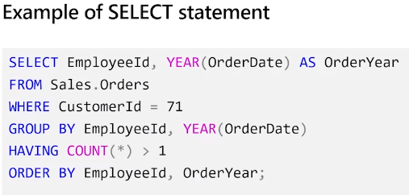

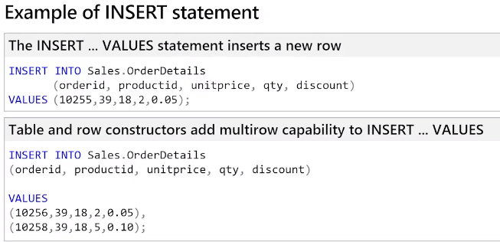

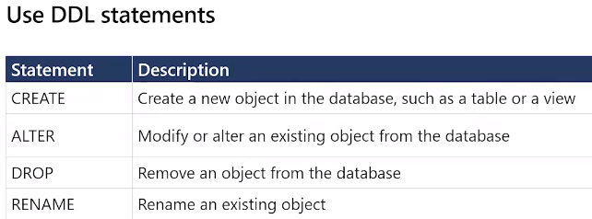

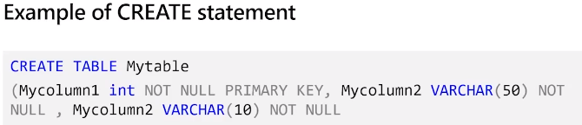

## Provision and Query Azure Database

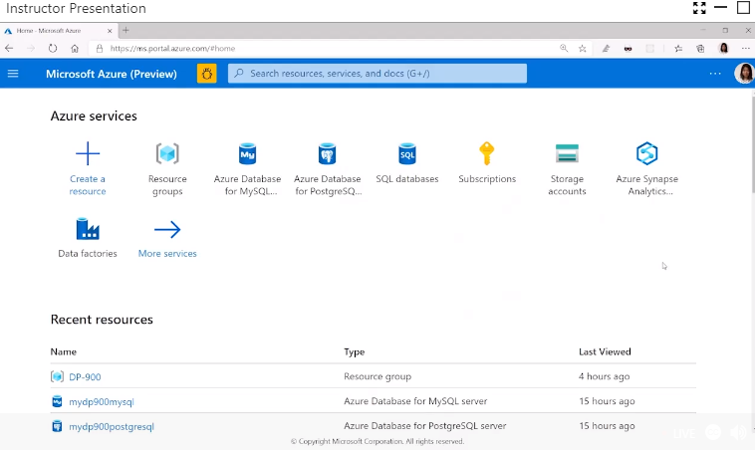

Menu bar or search for resource

Left hand menu bar or search for SQL dbase

Click Add

Go through settings as discussed above starting with basics

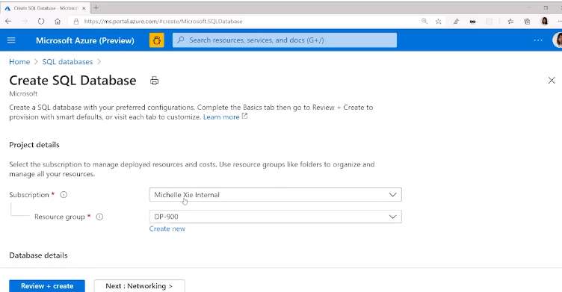

Pick subscription and resource group

Or create a new resource and group

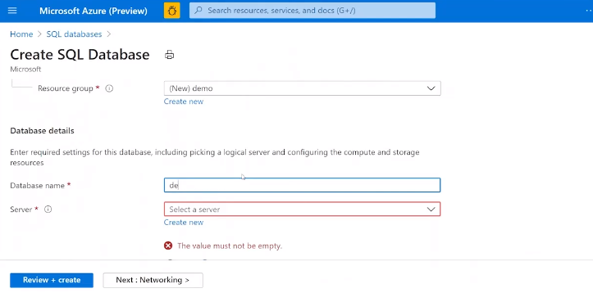

Give it a name

Then create a new sql server – unique name

Create virtual sql server for my azure dbase

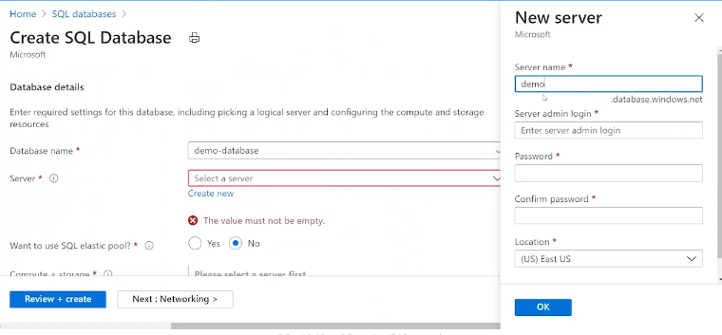

Must be a unique dame

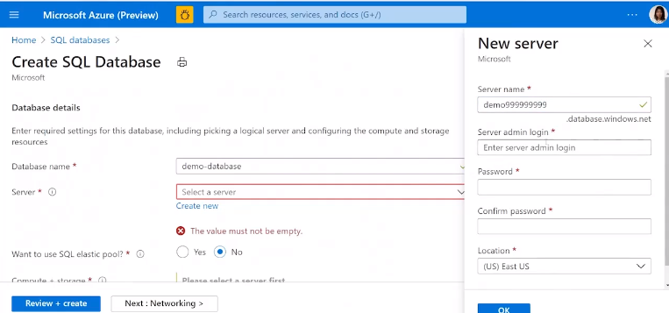

Give it credentials for login

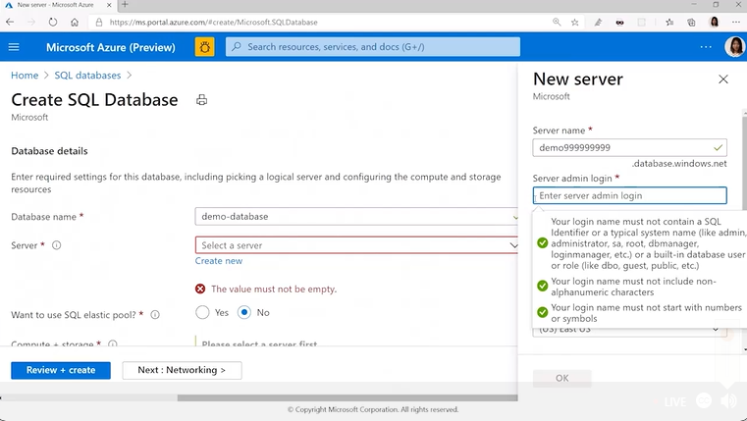

Give it credentials to login to the sql server

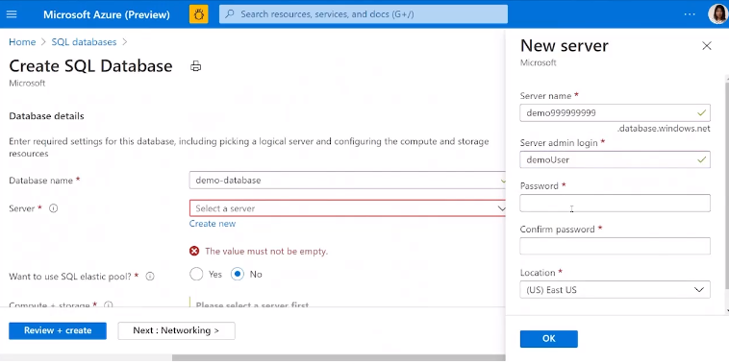

Location – select region from around the world

Click OK

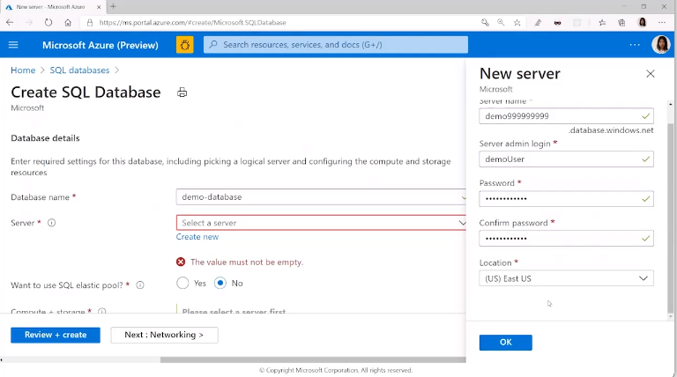

Location is the Azure sql dbase region we want to use

This sets up the SQL server for you

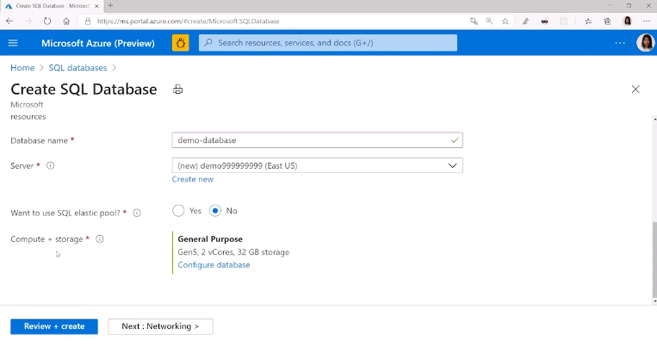

Elastic – yes or no

Set the config, size etc

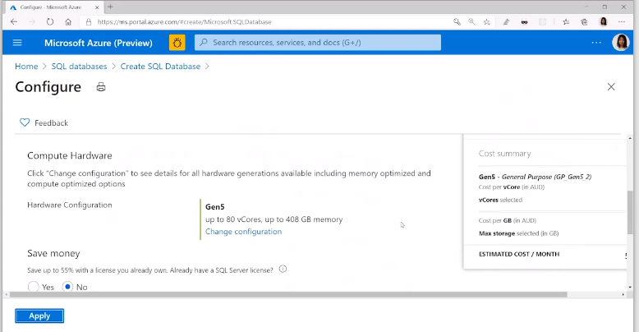

Prices for each option down below screen

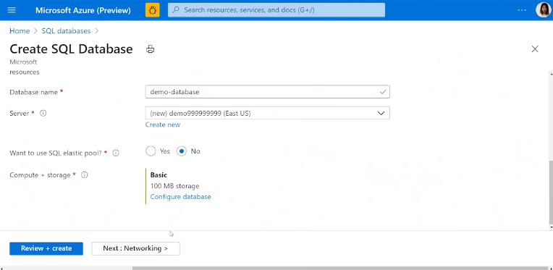

Shows price, click apply

**Networking**

Next is networking – how can access – public/private

Specify the access rules

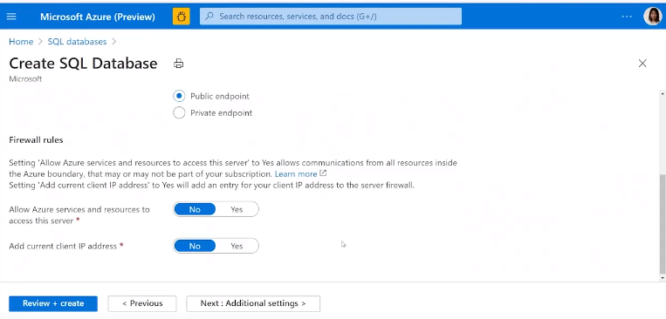

Additional setting – can specify data source

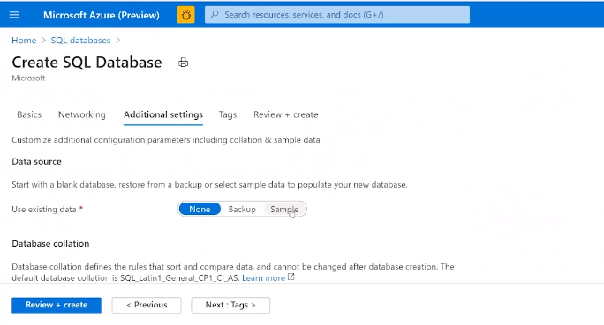

None = new, Backup = existing on-prem, Sample = sample Azure data databas

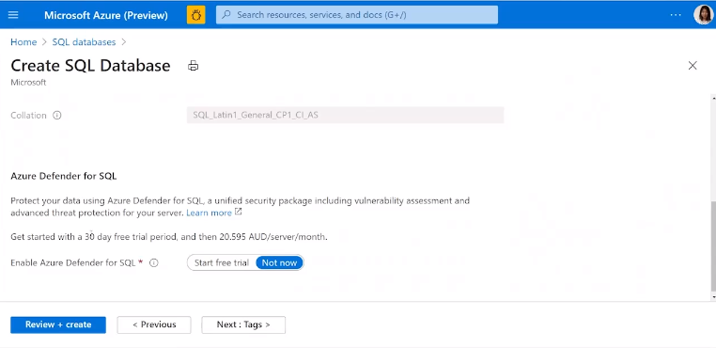

Azure defender – advanced protection for SQL Server

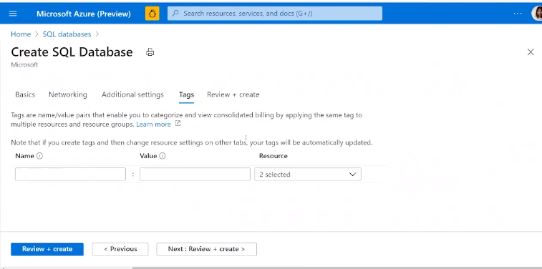

TAGS to add metadata to help find resources

Review and Create

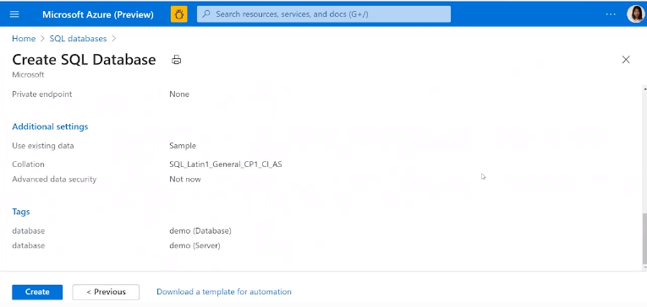

This will setup the database for you

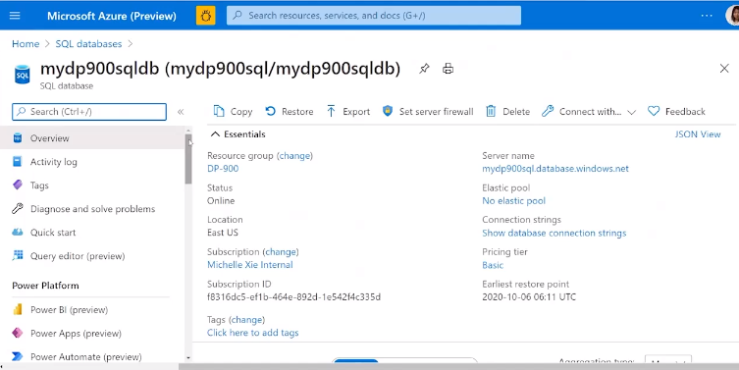

Overview shows info on the sql server dbase – on select of SQL DBase

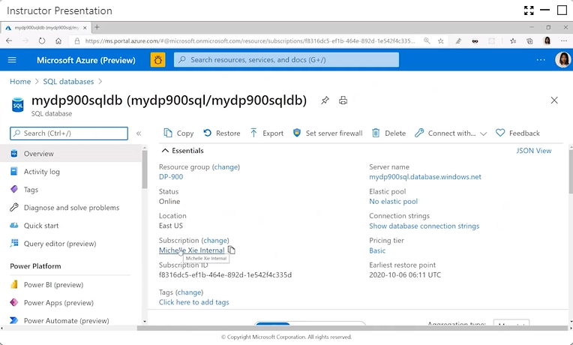

Select Query Editor from the side menu

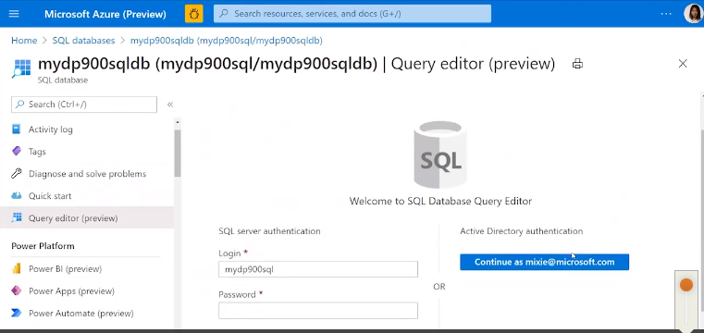

Can use AD of SQL Server authentication

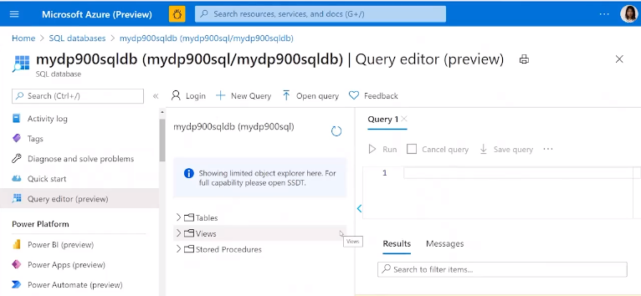

Need to verify myself 1st

Then can execute queries against the database

In the query editor can now execute queries

Query Editor

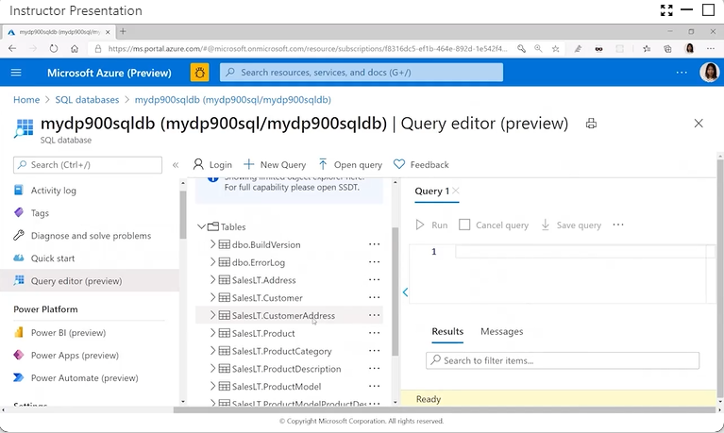

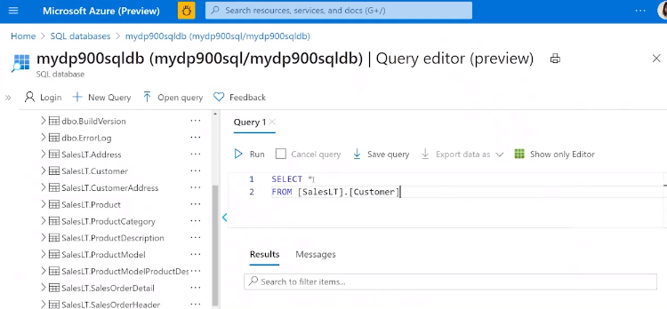

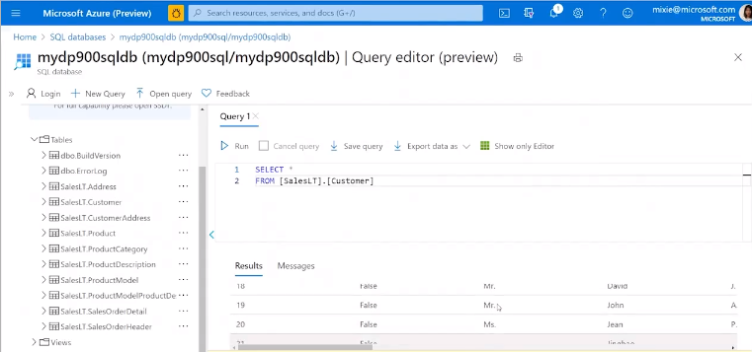

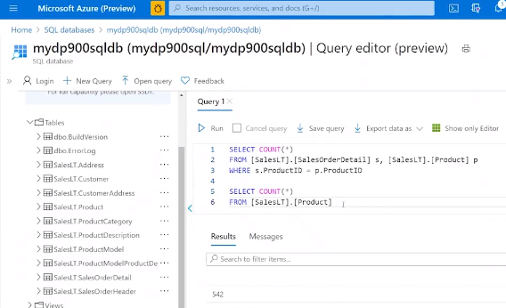

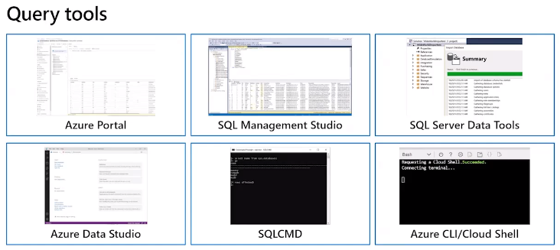

To use these tools

Need to establish connection to the dbase from the tool

SQL Management Studio – can download

SQL Server Data Tools – run within development tool

Azure Data Studio – build for ease of use

SQLCMD – authenticate then execute queries

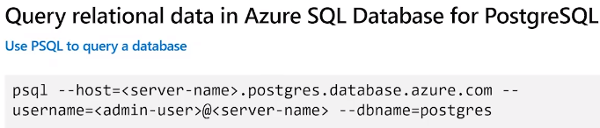

PG Admin – graphical user interface tool

PGSQL command line utility

3rd party utilities

Setup Postgres SQL database same as dbase creation above

Use PG Admin tool to connect and execute queries against Azure PostgresSQL

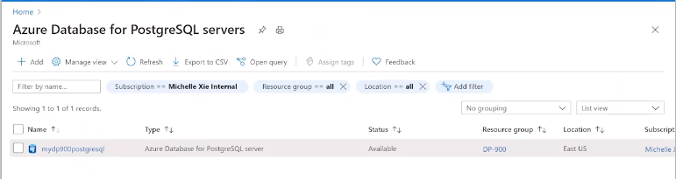

Need to setup and configure tool – same as above

Then go into tool

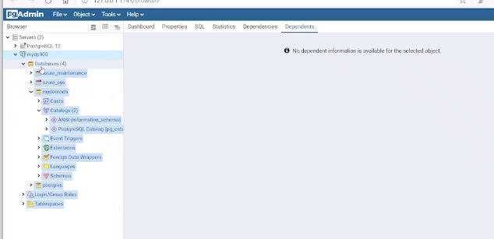

Create script to run queries against the database, like create table

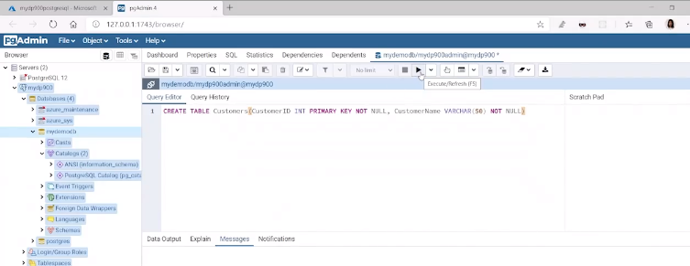

Play button to execute

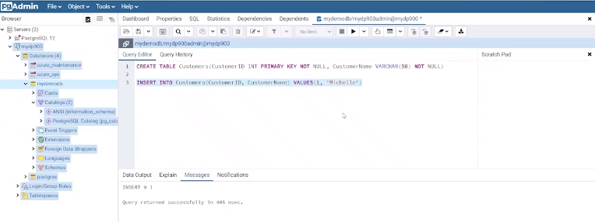

Highlight row to only execute the highlighted command

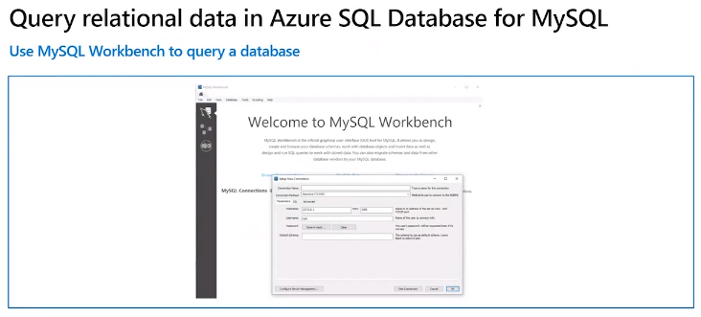

Provision MySQL database as above

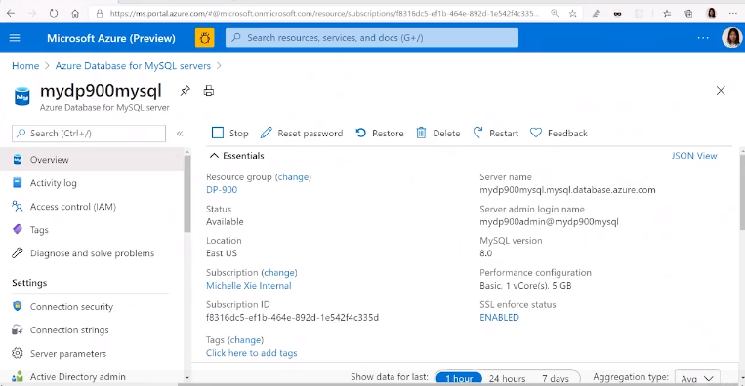

Go to MySQL Dbase (download app)

Open connection and provide password

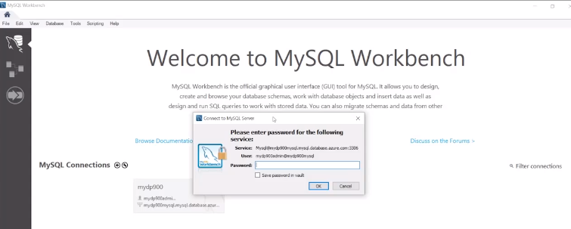

Write some queries

Highlight and run each one in sequence – lightning button to run

